Conjugate Match Algorithm-Based Synthesis of RCS Reduction Metasurfaces

Akila Murugesan, *Student Member, IEEE*, D. Rohit, R. Samyuktha, and Krishnasamy T. Selvan, *Senior Member, IEEE*

Department of Electronics and Communications Engineering

Sri Sivasubramaniya Nadar College of Engineering

Kalavakkam-603110, Tamil Nadu, India

*akilam@ssn.edu.in*

***Abstract*—****In this work, the Conjugate Match Algorithm (CMA) is employed for the first time to synthesize RCS reduction metasurfaces. CMA is applied to estimate the phase distribution of the metasurface that would result in a 10 dB RCS reduction of flat metal targets at normal incidence. The metasurface considered for the synthesis is of size 300 mm × 300mm with an inter-element spacing of 𝜆/2 at 10 GHz. The phase distribution thus estimated is realized using crossed dipole elements. A MATLAB code uses these data to generate the metasurface CST file for simulation. On simulation, the synthesized metasurface provides a bandwidth of 49% over the frequency range 5.7 – 9.4 GHz.**

Keywords—RCS Reduction, Conjugate Match Algorithm, Metasurface synthesis

# Introduction

Metasurface-assisted Radar Cross Section (RCS) reduction techniques have been widely researched in recent times. A comprehensive review of these techniques can be found in [1]. Both analysis-based and synthesis-based procedures have been employed for the metasurface designs. The metasurfaces synthesized in [2-4] have adopted the methods used for antenna array synthesis. Schelkunoff polynomial and phasor diagram techniques were used in [2] to synthesize checkerboard and graded-index metasurfaces. A transmission line based method is presented in [3] to synthesize Huygens metasurface. Another synthesis procedure based on Fourier transform is reported in [4] to develop coding and programmable metasurfaces for RCS reduction.

The conjugate Match algorithm (CMA) used for phased array synthesis [5] is adopted in this paper to synthesize RCS reduction metasurface. The desired pattern is to have a pre-determined, minimum radiation at boresight to ensure desired RCS reduction, which is in contrast to the synthesis of a phased array. To the best of the authors' knowledge, this approach is applied to the synthesis of RCS reduction metasurface for the first time. The element chosen to design the array is a crossed dipole. An automated MATLAB code is developed by making use of modified versions of some of the codes available in [6]. The code uses the phase distribution and the element characteristics to create the metasurface CST file for simulation. The designed metasurface offers an RCS reduction bandwidth of 49%.

The paper is organized as follows: Section II explains the CMA algorithm used to obtain the desired phase distribution of the RCS reduction metasurface. Section III describes the element design and metasurface modelling. Section IV discusses the results, and section V concludes the paper.

# CMA Algorithm

CMA is an iterative optimization algorithm based on the maximum array gain theorem described in [5] for phased arrays. The CMA optimizes the excitation magnitude and phase at each location in the array to obtain the desired radiation characteristics. In this work, we assume the reflection amplitude as constant, and only the phase is optimized to get the desired performance. The input parameters necessary for this synthesis algorithm are (i) the design frequency, (ii) the array size and (iii) the desired radiation pattern or footprint. The general procedure for employing the algorithm is as follows:

*Step 1: Initialization*

The inter-element spacing is chosen to be 𝜆/2 with respect to the design frequency, which in turn is used in estimating the number of elements based on the array size. The phase distribution of the elements is initially chosen to be constant over the array.

*Step 2: Realization of the footprint*

The coordinate position of the elements is obtained from the array size and interelement spacing. The footprint in (u,v) coordinates is estimated from the location of the elements and the phase distribution estimated using the expression [5]:

$F\left(u,v\right)=E_{P}\left(u,v\right)\sum_{n=1}^{N}{B_{n}\exp\left(jx_{n}u+jy_{n}v\right)}$ (1), where $E_{P}\left(u,v\right)$ is the element pattern, *N* is the total number of elements, $B_{n}=A_{n}\exp\left(jψ_{n}\right)$, where $A_{n}$ is the excitation amplitude and $ψ_{n}$ is the phase of the nth element, and $x_{n }$ and $y_{n}$ are the coordinates of the nth element.

*Step 3: Optimization:*

The cost function is defined to minimize the difference between the desired field strength (Fd(u,v)) and the estimated field strength F(u,v) by optimizing the excitation phase $ψ_{n}$ of each element. The maximum point of deviation is chosen for updating the excitation phase as per the following expression [5]:

$B_{n}^{new}=A_{n}\frac{B_{n}+ΔB_{n}}{\left|B_{n}+ΔB_{n}\right|}$ (2)

where, $ΔBn=\frac{ΔF\left(u,v\right)}{N\left[E_{P}\left(u,v\right)\exp\left(jx_{n}u+jy_{n}v\right)\right]}$, $with ΔF\left(u,v\right)$ being the difference between the desired and estimated footprints.

This procedure is repeated until the updated phase distribution satisfies the desired criteria. The phase distribution thus obtained is used to model the metasurface.

In this work, the design frequency chosen is 10GHz and hence the interelement spacing is 15mm. The overall array size is chosen to be 10 𝜆, which is 300 mm × 300 mm with 20 × 20 elements. The desired footprint is as shown in Fig.1.

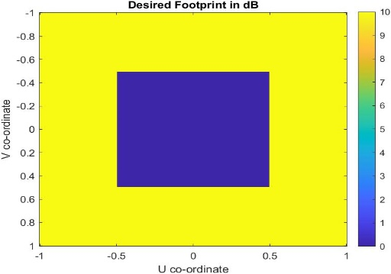

Fig. 1. Desired footprint

# Metasurface Modelling

The element chosen to model the metasurface is a crossed dipole. The unit cell is designed on a 1.57 mm-thick FR4 substrate over an airgap of 5mm. A parametric sweep is performed with the unit cell in CST to obtain the element size vs reflection phase characteristics.

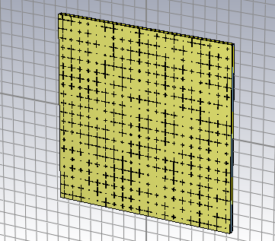

Fig. 2. Metasurface designed using the optimized phase distribution

The phase distribution and the element size vs reflection phase are used to model the metasurface in CST through an automated procedure written in MATLAB. The metasurface modelled in CST using the crossed dipole element is shown in Fig. 2.

# Results And Discussion

The synthesized metasurface is simulated for monostatic RCS reduction, and the observation is plotted in Fig. 3. The RCS reduction bandwidth for a −10 dB reduction is observed to be 49% over the frequency range 5.7-9.4 GHz.

Fig. 3. RCS reduction of metasurface array designed using the CMA.

The advantage of any synthesis procedure is that it could be used to design arrays that can have any desired pattern. The process considered here can be used to reduce RCS in any arbitrary direction, though we have considered the specular reflection direction. Also, this synthesis method can be extended to design other types of metasurfaces such as coding, phase gradient and polarization conversion metasurfaces.

# Conclusion

This paper reported a conjugate match algorithm-based synthesis of RCS reduction metasurface. The optimized phase distribution obtained from the CMA algorithm and the phase response characteristics of a cross dipole element were used to generate the metasurface array in CST by an automated process interfacing CST and Matlab. The simulated 10-dB RCS reduction bandwidth of the metasurface was observed to be 49% over the frequency range 5.7-9.4 GHz.

# References

[1] A. Murugesan, K. T. Selvan, A. Iyer, K. V. Srivastava, and A. Alphones, "A Review of Metasurface-Assisted RCS Reduction Techniques," *Progress In Electromagnetics Research B,* vol. 94, pp. 75-103, 2021.

[2] A. Y. Modi, C. A. Balanis, C. R. Birtcher, and H. N. Shaman, "New class of RCS-reduction metasurfaces based on scattering cancellation using array theory," *IEEE Transactions on Antennas and Propagation,* vol. 67, no. 1, pp. 298-308, 2018.

[3] J. P. S. Wong, M. Selvanayagam, and G. V. Eleftheriades, "Design of unit cells and demonstration of methods for synthesizing Huygens metasurfaces," *Photonics and nanostructures - Fundamentals and Applications,* vol. 12, no. 4, pp. 360-375, 2014.

[4] S. Liu and T. J. Cui, "Flexible Controls of Terahertz Waves Using Coding and Programmable Metasurfaces," *IEEE Journal of Selected Topics in Quatum Electronics,* vol. 23, no. 4, pp. 1-12, 2017.

[5] A. K. Bhattacharyya, *Phased array antennas: Floquet analysis, synthesis, BFNs and active array systems*. John Wiley & Sons, 2006.

[6] <https://in.mathworks.com/matlabcentral/fileexchange/67731-hgiddenss->cst_app - Accessed on 26-01-2022